Invitation Swedish Championship & Swedish Cup,
2021-7-31 - 2021-08-01 round no. 1 and 2

Jetsport Club Lidköping (JSCL) in cooperation with Orust Jetski Klubb (OJK) invites all riders, mechanics and officials to the premier of 2021 Swedish championship races. Race site is JSCL practice-site in Lidköping (58°30'21.1"N 13°10'43.6"E)

The Corona pandemic is not over - this invitation are subject to changes up to the date of the race. Keep a close look at Your mail and Svemo´swebsite.https://www.svemo.se/Sporter/tavlingskalender/Vattensporterna/.

IF THE RACE IS CANCELLED, THIS WILL BE NOTIFIED THURSDAY JULY 22 AT THE LATEST.
ALL INFORMATION BELOW CONCERNES BOTH RACES 31/7 AND 1/8!

NOTE! IN ORDER TO ARRANGE THESE RACES, THE FOLLOWING RULES REGARDING COVID 19 MUST BE OBEYED:

- All riders must, no later than july 19,submit their application, present a valid and paid racelicense and also pay the entryfee – see ”registration” below. No registration will be accepted on site due to Corona-rules.

- All riders are allowed to bringone (1) mechanic/holder(two (2) persons for the R/A classes). Pls note that persons only immediately involved in conducting the race will be allowed on the race site.

- Only persons complying with paragraph 1-2 will get access to the race site, a bracelet will be presented as a race pass. The entrance will be under supervison of race official.

- No marketing of the race will be allowed in order to obtain a no-”audience-free” race. The organizer asks kindly that we all refreigns from using social media or in other ways attracting visitors.

- Every individual within the race site must obey rules and regulations stipulated by Folkhälsomyndigheten, Riksidrottsförbundet and Svemo. It is each participants duty to have full awareness of these rules. See spec at the bottom of this document.

- International riders are allowed to participate as long as restrictions and guidelines given for coming and leaving the country can be followed. Pls make sure You are up to date of your countrys status in this matter.

- Persons not following the regulations stated will be asked to leave the premises.

- Tech inspection will be performed in a dedicated area where only rider and tech officials will be allowed. After approved inspection, the participant will be noted on the startlist and is thereby approved for take part in the race.

- All personal equipment must be held separate from others i.e. clothes, food, helmets, tools etc.Only the most necessary will be allowed in the pit.

- Riders breifing may be held digitally where information will be e-mailed to the adress presented by each participant in their entry form. It is mandatory information and will be available no later than july 30, 13,00.

- Special rules regarding positioning of vehicles/scoters in paddock and pit will apply. ONLY equipment necessary for conducting the race will be allowed in the pit.

- There will be no food or beverage sold at the race site so bring what You need for Your personal comfort during the event.

- All participants will bring hygenic alco-gel for their own personal use.

- Facemask is recommended as per national authorities recommendations and should be worn by everybody within the race site. Riders with helmets on are excluded. Facemask is brought by each participant to be worn as per manufacturers recommendations.

- There will be no trashcans/containers on the race site. ”What you bring is Your responsibility to also bring with you whenYou leave.”

- If possible, avoid staying over night in the pit.

- Prizegiving will be held at a later date. Trophies will be presented to the top three in each class and only as a total champion prize winners, not for each race.

ALL THE ABOVE MUST COMPLY WITH WHAT IS PRESENTED TO THE POLICE IN ORDER TO GET APPROVAL TO ARRANGE THESE RACES. IF CIRCUMSTANCES CHANGES, ALL OF THE ABOVE ARE SUBJECT TO ADJUSTMENTS.

Raceformat:

The races will be carried out according to present rules of Swedish Championship standards.

Pls note that each day counts as a separate round in the Swedish Championship, i.e. Saturday and Sunday = two rounds/races

For each race (day)each class will be executed in two moto slightly longer than what is standard. During first part of the day, 3-4 classes will finish their motos. After that, we will alter groups so the remaining classes takes over the race-pit and the first group returns to the paddock. Startorder will be presented in the startcomfirmation afterYou finalizeYour entry form.

Below information involved both round no. 1 and no. 2

Rules

According to UIM rulebook, Svemo Aquabike-regulations and its amendments. Smoking is not allowed anywhere inside the designated race area. All handling of fuel takes place on land with fuel-mat as per information given at the riders meeting held digitally. NOTE: race numbers according to UIM regulations

Organizer: JetSport Club Lidköping
Race director: Thomas af Klinteberg
Ass. Race director: TBA
HeadofSecurity: TBA
Svemo-representative: TBA
Pit-official: Dennis Apell
Corona-official: Maria Helgeson
Rookie-official: Tommy Jacobsson
Jury: TBA

Schedule: 07.00 Open pit
08.00-09.15 Technical inspection
09.30 Riders briefing
10.00 Practice group 1
11.15 Heat, group1
12.30 Lunch break
13.30 Practice group 2
14.45 Heat, group 2

Classes:

Ski:Junior GP 3.2 and GP 3.3, GP 3, GP 1 Veteran 40, GP1 and GP 1 Ladies
R/A: Junior GP 4, GP 4, GP 3, GP 2 and GP 1
Classes may be mixed or cancelled if not enough entrys.

Registration/ registrationsfees

Registrationfee Swedish Championship race 1. senior (junior) 900 sek (500 sek)
Registrationfee Swedish Championship race 2. Senior (junior) 900 sek (500 sek)

Registrationfee joint payment both races above: 2x700 (450) sek/race = 1400 sek (900 sek)

Extra class: 300 sek

Registration and paid entry fee must b done and available/visible to the organizer no later then july 19.
Late entry will be charged double fee and is accepted up to Thursday july 29.
Refund may be accepted with 50% if cancellation of entry is made Thursday july 29 for race 1 and Saturday july 31 before 18.00 for race 2.
By registrating each participant fully complies to follow all rules and requirements in this document and also agrees to follow the safety plan (will be sent to all participants by e-mail).

Registration and entry fee must be presented on time and race license must be valid.
Entry fee must be paid no later than july 19 to swish no. 1236884274 and write ”drivers name+SM” in comments. If you not are able to use Swish we recommend You to contact Oscar Helgesson +46 70-738 49 33 or Håkan Borgström +46 70-558 78 71 to secure that Your entry fee will be granted

Note! Maximun one swish payment per driver, not allowed to swish entry fees involving more than one driver in each swish payment!

Registration no later thanjuly 19 to: dennisapell@gmail.com

Pls. Submit following information:
1. Name, address, mobile phone no. and e-mailaddress
2. State which races the entry applies to (a single race or both SM1/SM2)
3. Accompanied by person… name and phone no.
4. Requests camping in the pit during Friday-Sunday.
5. Race no. on aquabike/s
6. Race class, brand on aquabike, model

NOTE! Only registrations filled out properly will be accepted!

Start confirmation.

NOTE! Your entry will be confirmed by e-mail and it is vital that all riders reads and understands the contents in this document that may substitute the riders briefing. It is mandatory to be awareof this information and random controls there of will be performed.

Arrival on site:

The paddock opens Friday july 30 at 18.00. Large vehicles like busses/trucks must be pre-registered with Andreas Gustavsson phone no. +46 768 474999. Pls respect the instructions given of where to put your equipment.

Accomodation:

There are several accomodation alternatives within walking distance in Lidköping, use google!

The paddock will be held open Fridayjuly 30 between 18.00-20.00 for those who prefer to stay there for the night, (see p. 11 & 16)
No electricity or water avaliable, toilets only.

Important dates:
July 19 Last entry date to register and get early-bird entry fee
July 22 Deadline for organizer to cancel race if not enough entries
July 29 Last day to with draw entry for a limited re-fund of entry fee, race 1 (Saturday)
July 29 Last entry date to register, late entry=double entryfee
July 30 13.00 – digital riders briefing sent to each participant thru mail
July 31 18.00 is last time and date to with draw entry for a limited re-fund of entry fee, race 2 (Sunday)

Welcome to Lidköping!

Do not forget alco-gel, fire extinguisher and fuel-mat

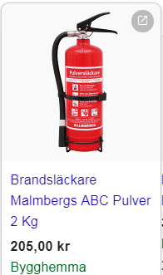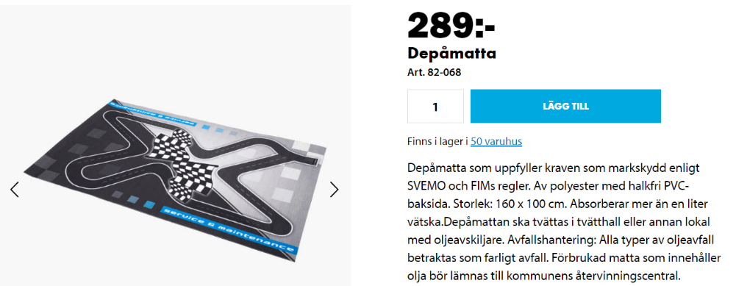BILTEMA

Covid 19 affects people differently. Most infected developes mild to medium type of symptoms and will recover fully without medical attention.

Common symptoms are:
Fever
Drycough
Fatigue
Less commin symptoms are:
Ache in muscles and limbs
Sorethroat
Diarea
Inflamation in eyes
Affected sense of smell and taste
Rash and/or discolored fingers and toes
Serious symptoms are:
Fatigue and shortness of breath
Chest pain or pressure over chest
Imparedability to speak and move

The above symptoms are cause for seeking immideate medical attention. Always call in advance before leaving for any kind of medical care
Persons with mild symptoms with good health status are advised to stay at home until fully recovered. It takes generally5-6 days from moment of virus exposure until first symptom occurs but in some cases even up to as much as 14 days.

